|  |  |
| --- | --- |
| **NAME :** | DHANANJAYAN L |
| **DEPARTMENT :** | ELECTRONICS AND COMMUNICATION ENGINEERING |
| **COLLEGE :** | GOVERNMENT COLLEGE OF TECHNOLOGY |
| **NAAN MUDHALVAN COURSE:** | DIGITAL MARKETING |
| **NAAN MUDHALVAN ID :** | 7434F9A0F28CD6F9A694BEAC10099366 |

ASSIGNMENT ON DIGITAL MARKETING

1. Create a blog or website using blogspot and wordpress.Customize the theme design and post new article with 500 words.

Blogspot:

<https://dhananjayann.blogspot.com/2023/08/chandrayaan-3.html>

Wordpress:

<https://ldhananjayan2002.wordpress.com/2023/10/28/chandrayaan-3/>

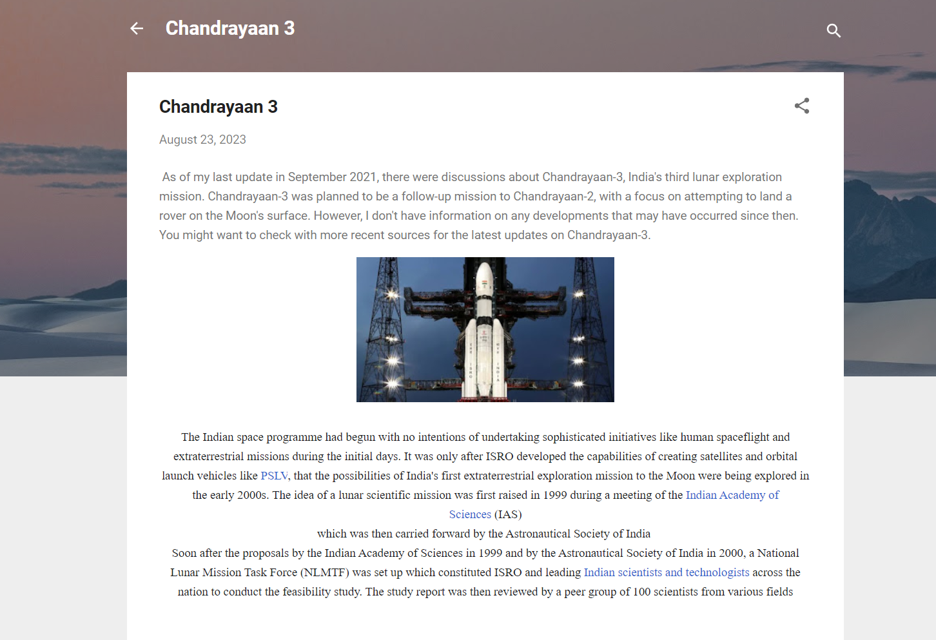

2.Create and design a social media advertisement poster using canva.

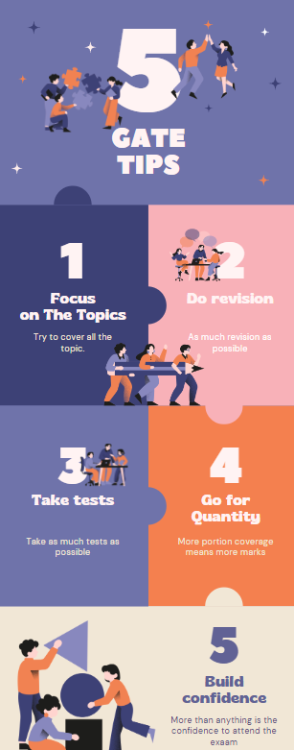

Create email newsletter design using Mailchimp or canva tool

